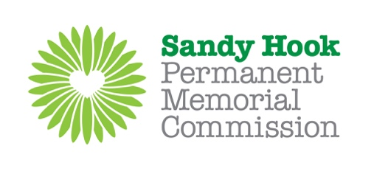
Phase I B Design Evaluation

Use as much space as you need per design to send through your own thoughts on each of the 13 designs. Feedback is open-ended, anecdotal and based on personal preference. We recognize there will be different viewpoints here, but want to ensure we understand what you love, what you dislike and any considerations you have.

UNIQUE CODE | THOUGHTS ON DESIGN
SH37

SH66

SH81

SH102

SH108

SH141

SH147

SH179

SH203

SH217

SH233

SH240

SH279

Upon completion, please email feedback to: CommunitySHPMC@gmail.com.
Please do so by 04/8/18

